**Question 1**

**Consider the circuit shown in Figure with v(t) = 10e-9t V and i(t) = 5e-8t A for t >= 0. Both v(t) and i(t) are zero for t < 0. Find the power supplied by this element and the energy supplied by the element over the first 100 ms of operation.**

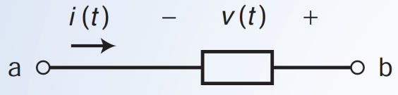

**Question 2**

**The current i(t) in a 2H inductor connected in a telephone circuit changes according to**

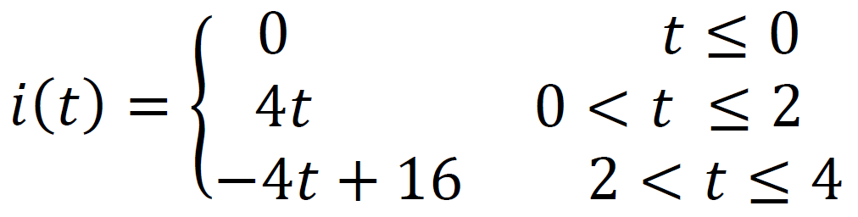

**Where unit of time is second and the unit of current is mA. Determine the power p(t) absorbed by the inductor and energy w(t) stored in the inductor.**

**Question 3**

**A 4 mF capacitor has the current waveform shown in Figure. Assuming that v(0)=10 V, sketch the voltage waveform v(t).**

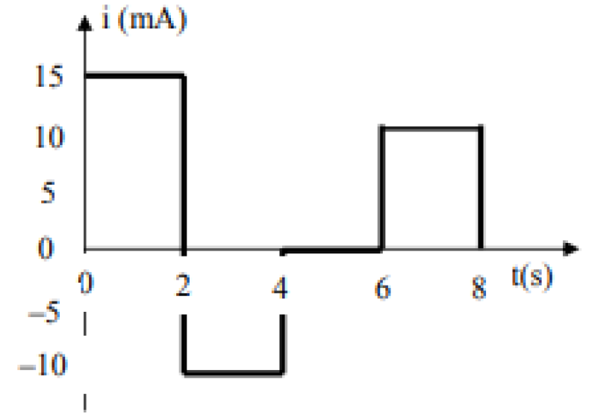

**Question 4**

**Calculate the current drawn from a 12-V supply with internal resistance 0.5 Ω by the infinite ladder network, each resistance being 1 ohm, in Figure.**

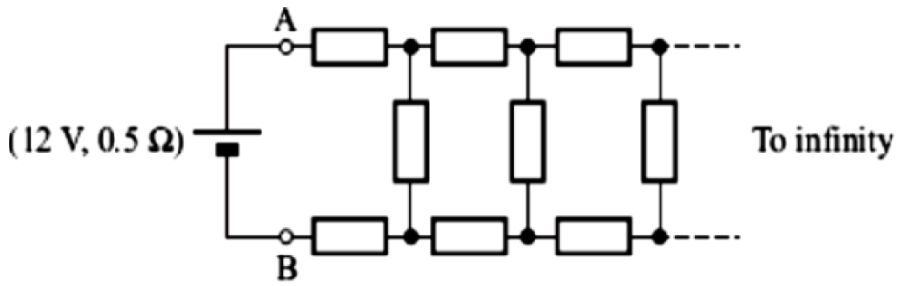

**Question 5**

**Using only 1K resistors, synthesize a resistor of 3/5 K and 5/3 K. You can use maximum 4 resistors in each case.**

**Question 6**

**The average current in a typical lightning thunderbolt is 2 x 104 A, and its typical duration is 0.1 s. The voltage between the clouds and the ground is 5 x 108 V. Determine the total charge transmitted to the earth and the energy released.**

**Question 7**

**An energy source forces a constant current of 2 A for 10 s to flow through a light bulb. If 2.3 kJ is given off in the form of light and heat energy, calculate the voltage drop across the bulb.**

**Question 8**

**How much energy does a 100-W electric bulb consume in two hours?**

